|  |
| --- |
|  |
| BM CONSTRUCTION  ***COMPANY PROFILE*** |
| |  |  |  | | --- | --- | --- | | Rated best. | 9/25/00 | FOR TILING | |

000

**BM CONUCTION**

*"Our mission is to remain reliable and*

*efficient at the forefront of the Zambian construction industry through quality, honesty, and hard work"*

*call +260979400711*

*+260966712895*

*+260955388835*

*Email :bennymusonda@live.com*

**An**

**Introduction**

BM Construction, a pioneer in construction activities

established in 2000. Since then, the Company has continued to deliver the best value in building services by placing expert construction professionals in all their projects.

BM Construction has always ranked among the leading firms in the industry, and has successfully completed some of the most challenging and iconic projects in the Country.

*" BM construction has worked on a diverse range of*

*projects, including , hospitals , schools, sports centers and commercial and residential buildings"*

**Key Organizational Values**

**Ethics**

We at BM CONSTRUCTION remain true to our founding values of providing quality, honest and hard work, instilled right from the outset by our founder.

We endeavor to adhere to the highest ethical standards in the industry. We have been accepted by the construction industry as a trustworthy business by being consistently associated with integrity, high standards and quality of service and personal attention to clients. As a result of this reputation, BM CONSTRUCTION has the honor and privilege of leading some of the highest profile projects in ZAMBIA.

**Staff**

We recognize that our primary asset is our people, and that a truly successful company needs to be a rewarding work environment for its staff. Our organization is structured and managed to provide ample opportunity and encouragement for our team to reach their optimum potential. We believe that mutual respect forms the base of our success.

**Philosophy**

Lasting relationships are the lifeblood of business in our industry. At all times, we strive for solutions that best achieve our client’s needs and

goals. Our staff’s ability and commitment to finding these solutions is what distinguishes us. We provide consistent personal and individual attention to all our clients.

**Services**

As a full-service construction company, BM CONSTRUCTION essentially assists clients from the very outset to the completion of their project. We become partners with our clients in understanding the five basic functions of:

• Defining and establishing the scope of the construction project

• Pre-construction project planning including preparation and scheduling of the projects, phasing plans, budgeting/cost-modeling, subcontractor qualification etc.

• On-site execution of the project includes scheduling, quality control, safety management, subcontractor management, status reporting and change management.

• Monitoring and controlling the project

• Closing of the project related to the post construction activities.

**Project Delivery Methods**

BM Construction builds a diverse range of projects for both government and private clients under a variety of project delivery methods including:

• Plans 2d and 3d drawing

• Construction Management

• Design-Build Development

• Pre-construction Service

**Project**

**Experience**

BM CONSTRUCTION S diverse includes new construction as well as renovations. Some of the major projects are:

❖ Countless commercial and domestic houses in Zambia.

❖ Most of the shopping malls in Zambia.

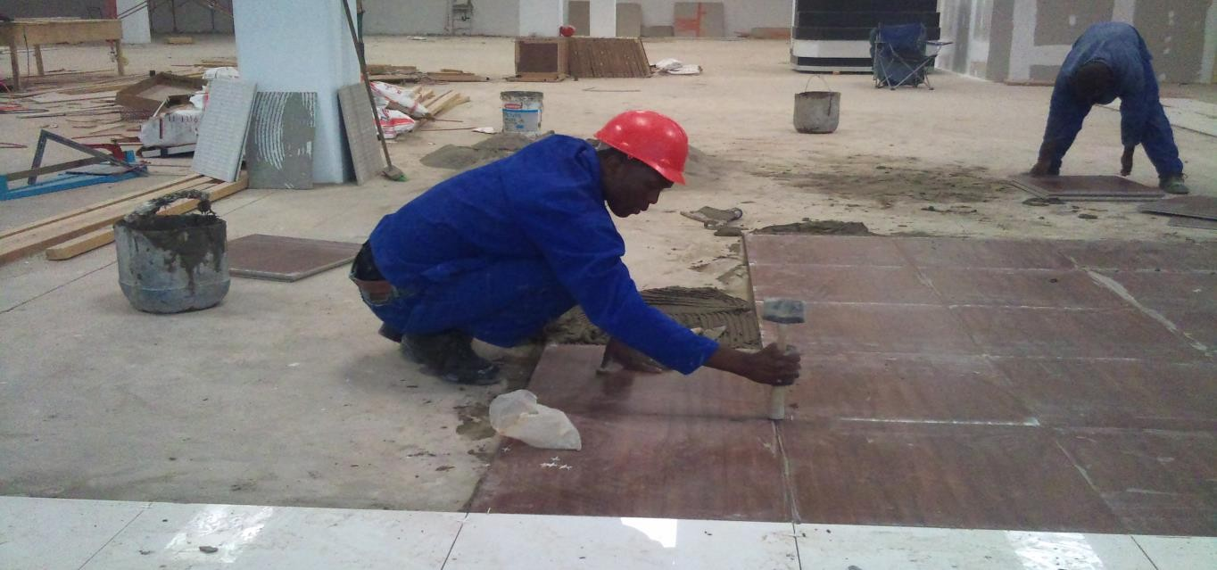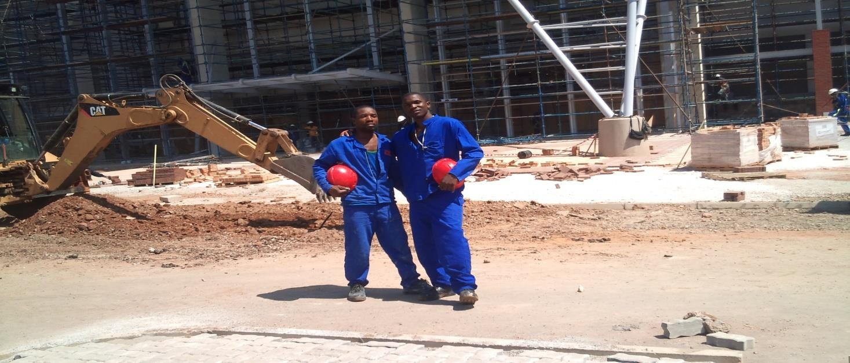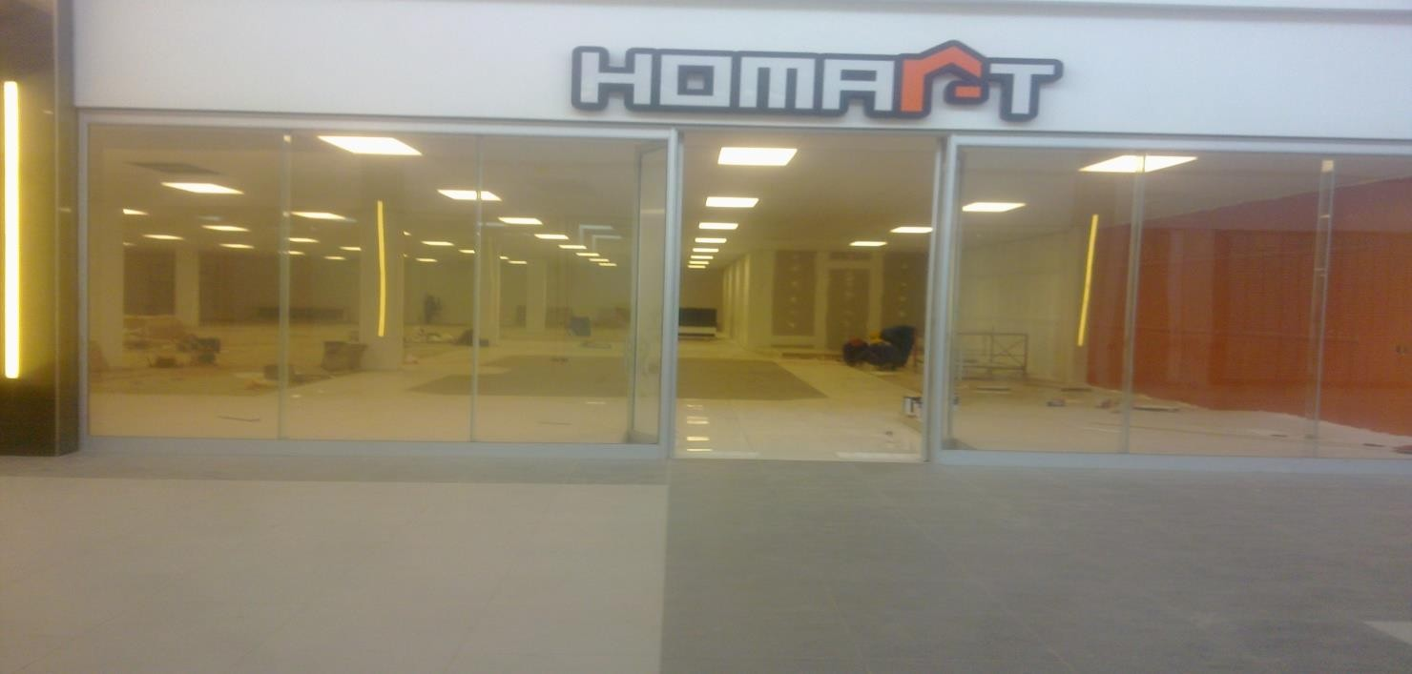

Tuesday, October 25, 2011 levy mall. Work we did tiling. Location Lusaka.

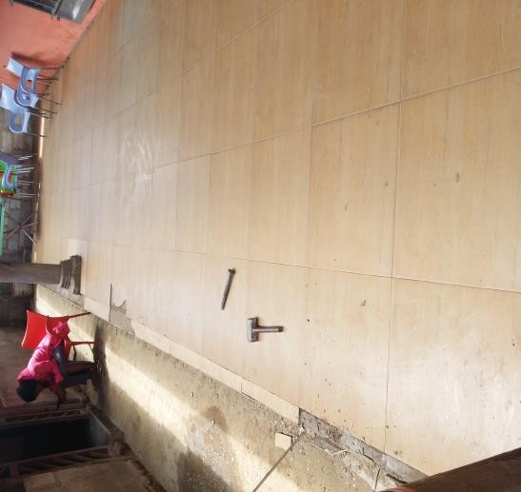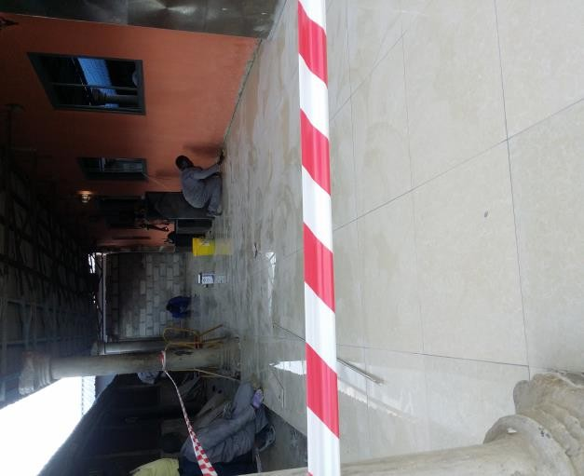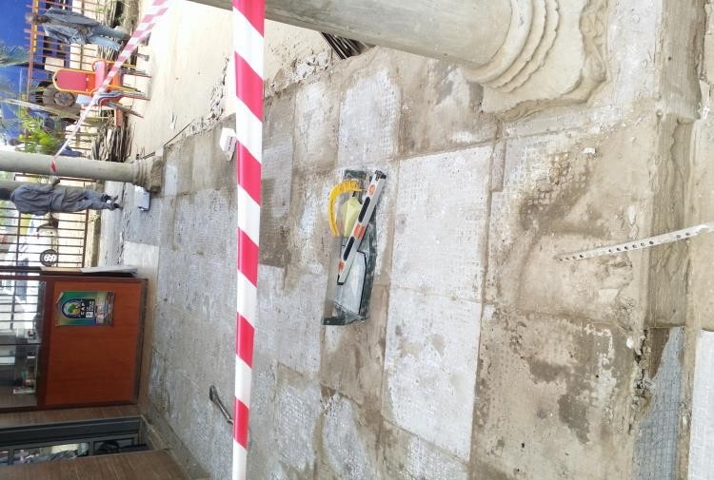

renovation removing old tiles and re tiling. Location Lusaka 2017.

Brick work and plastering. Locations chibombo , new kasama and roma..

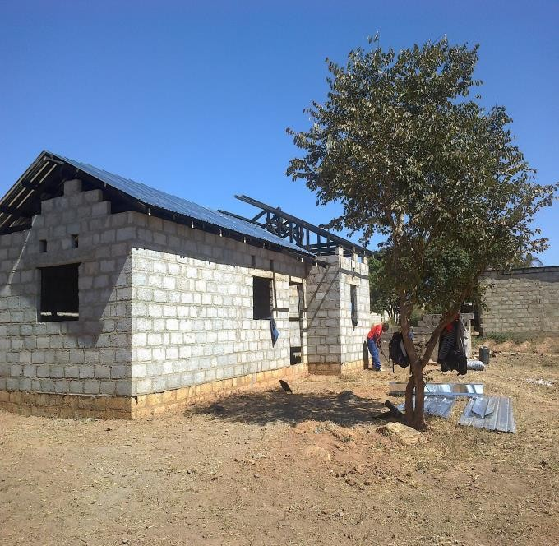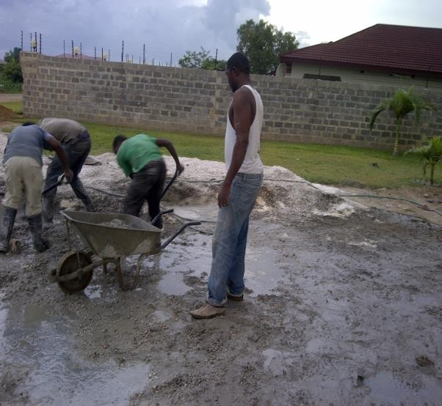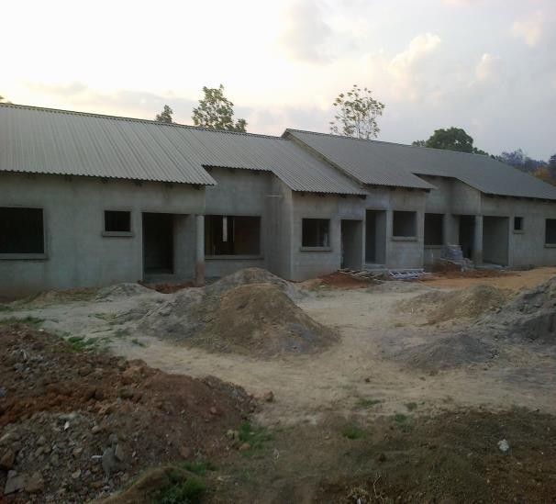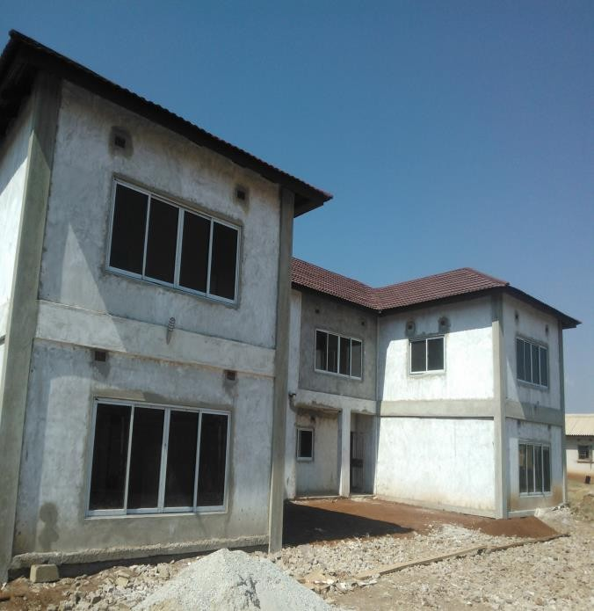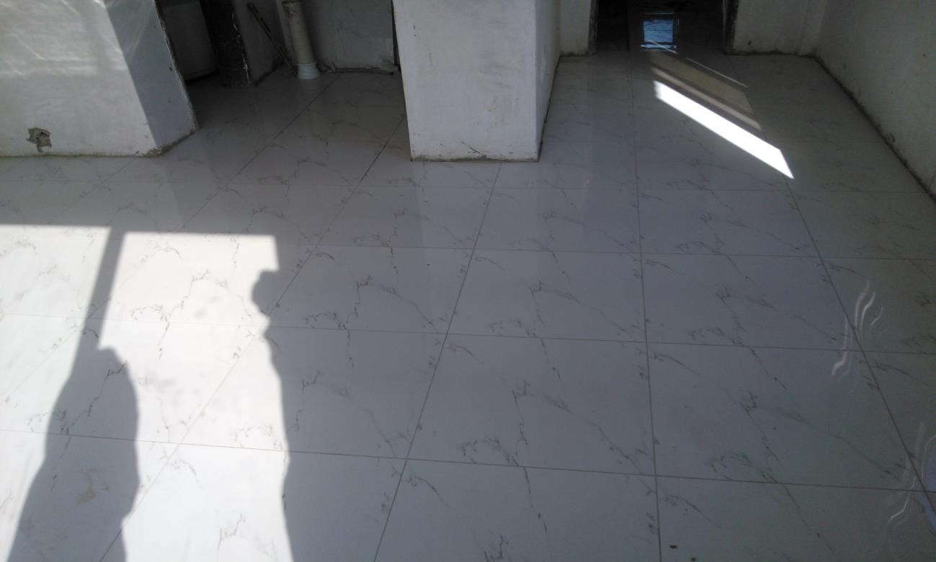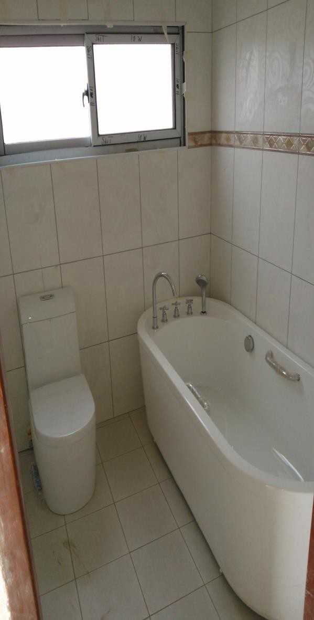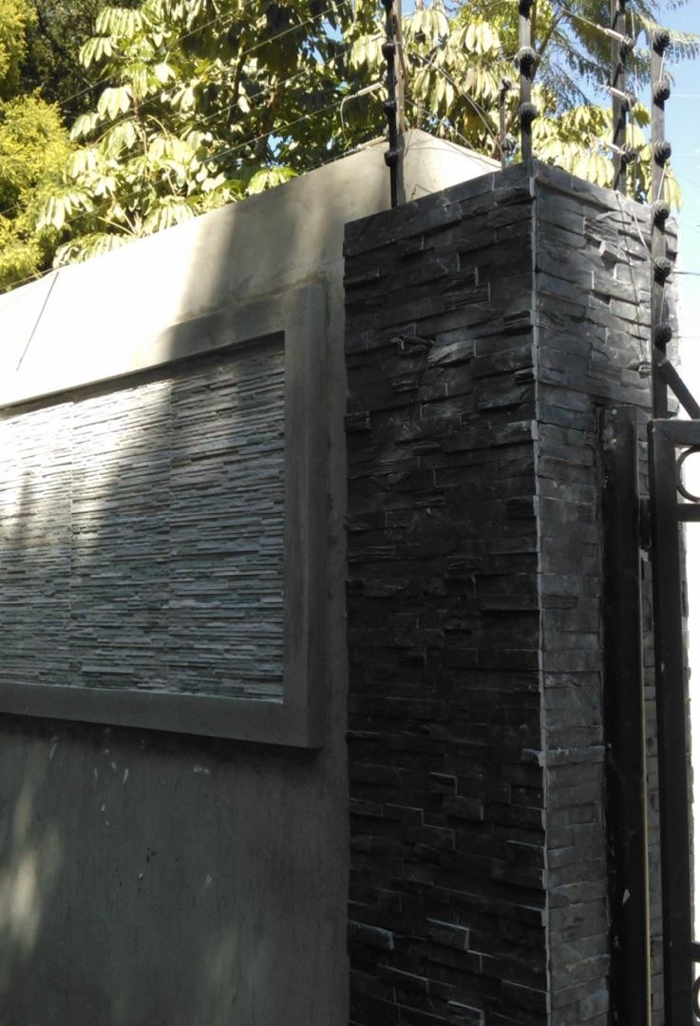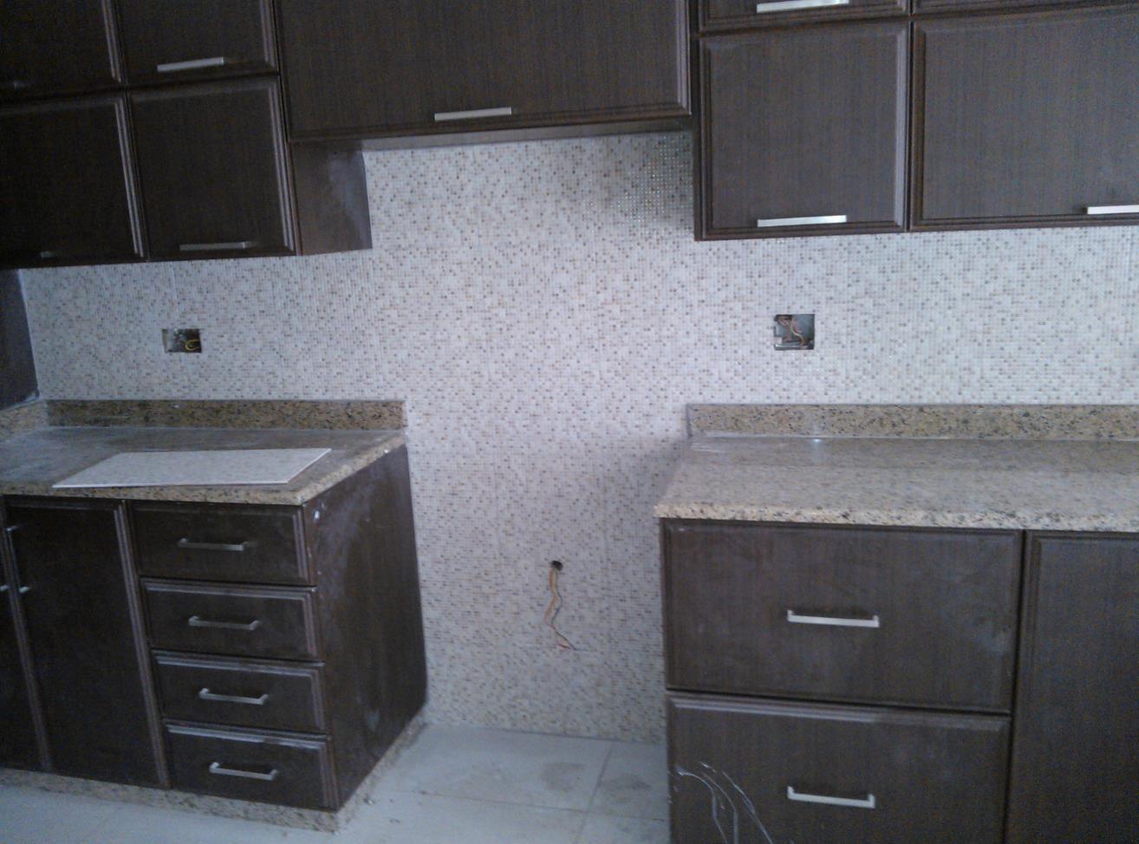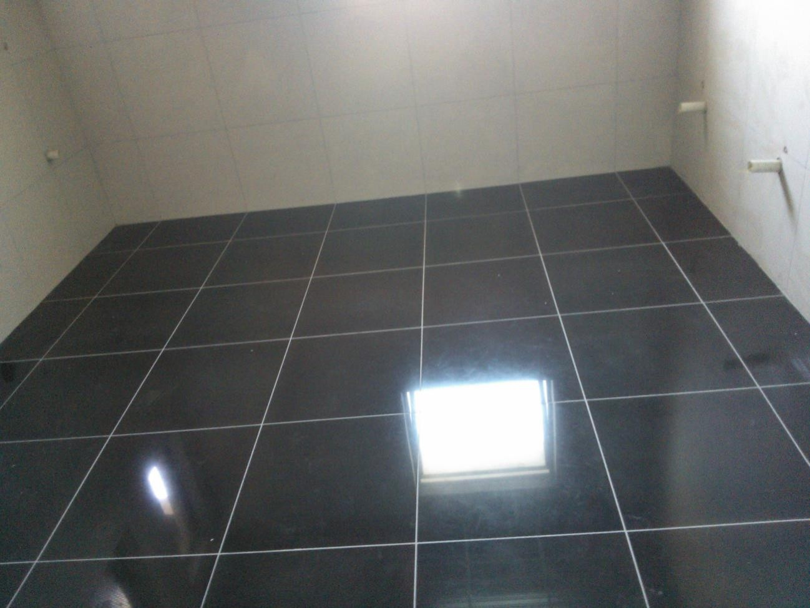

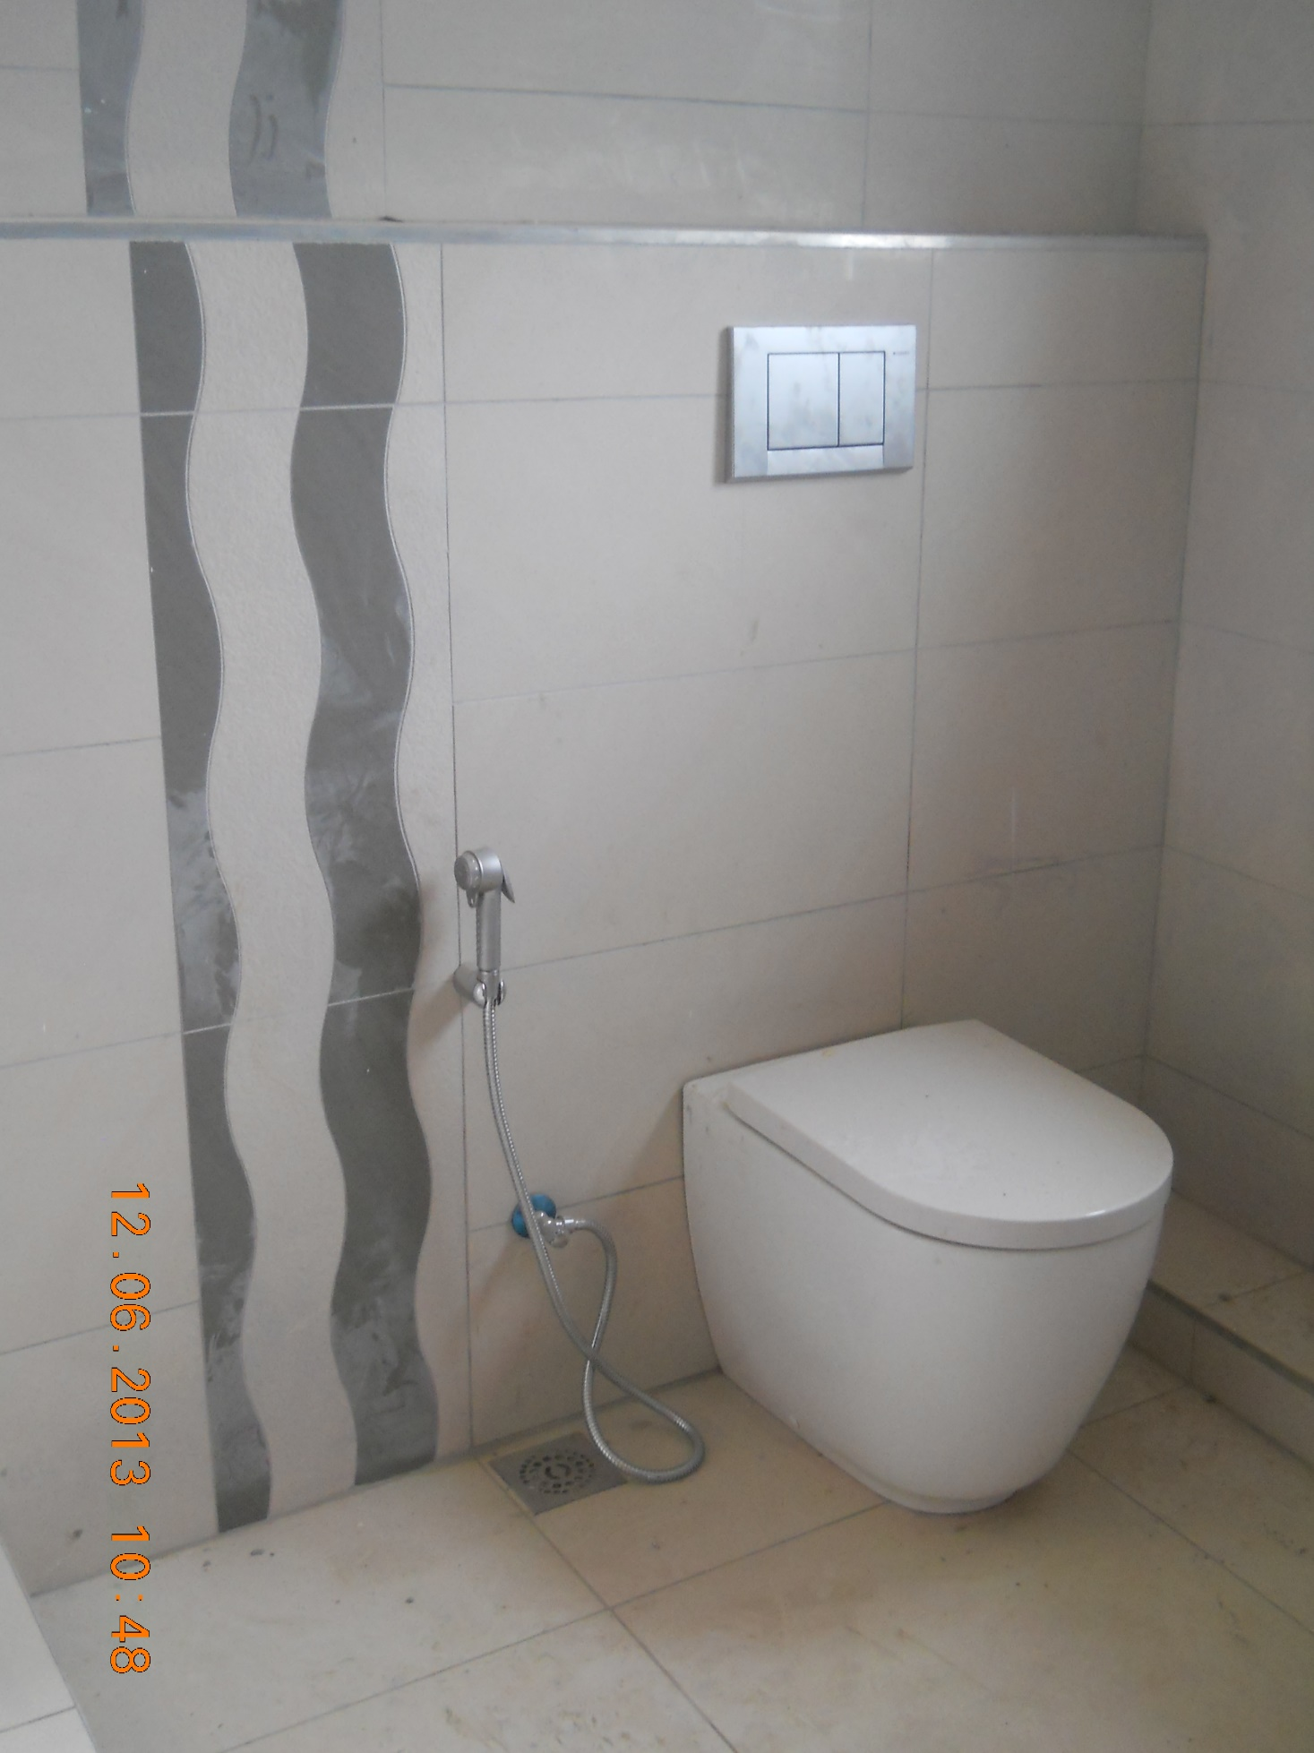

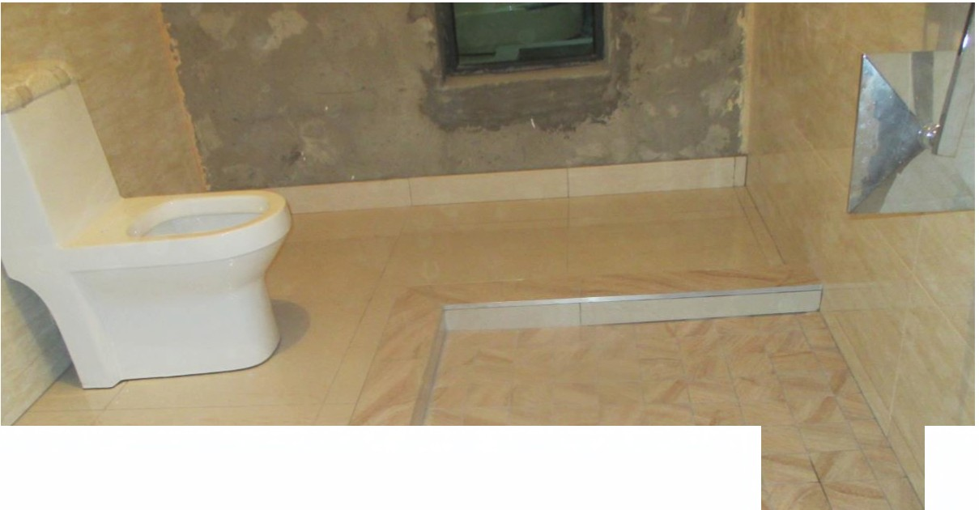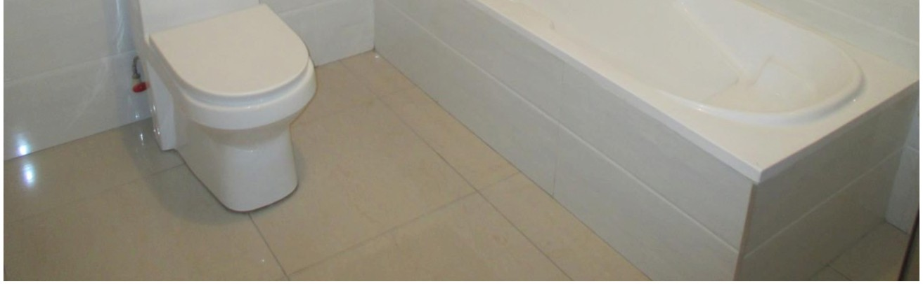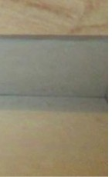

•

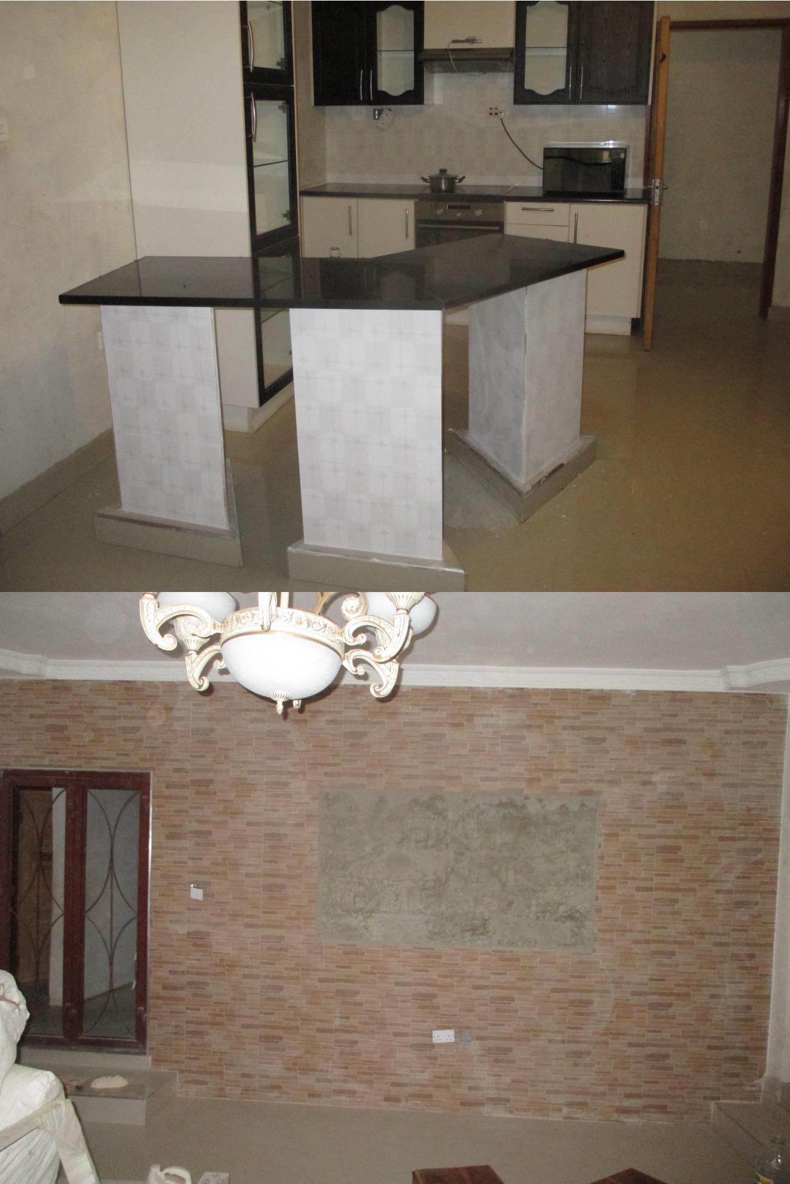

All the customers we have worked for are satisfied, we do the best work.

